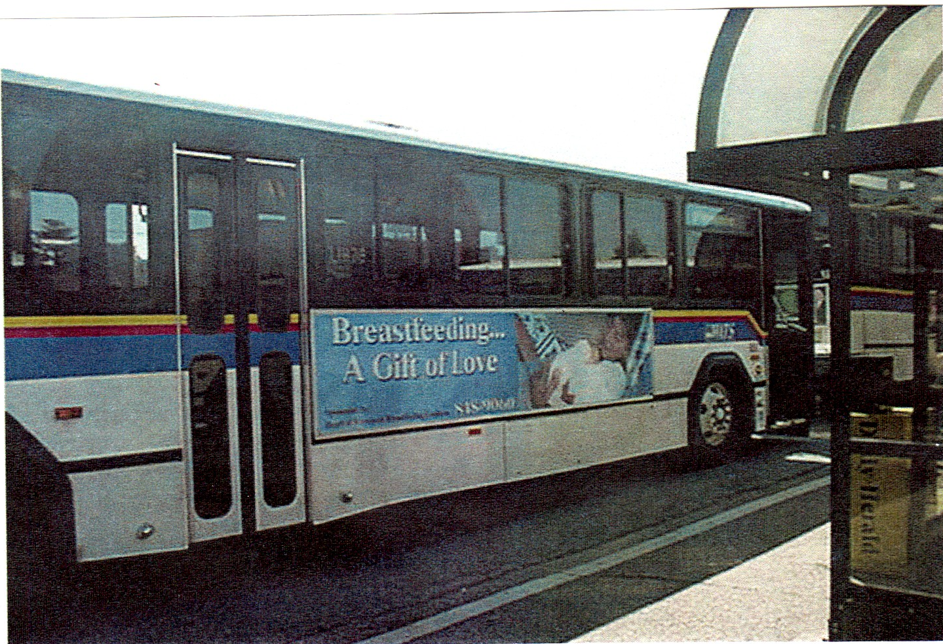

Heart of Wisconsin Breastfeeding Coalition
“A partnership to promote health in women and children through the promotion of breastfeeding as the cultural norm”
Breastfeeding has been proven to be of primary importance in promoting health and protecting against disease in infants and their mothers. Our coalition was formed in 2000 by a core group of lactation consultants and physicians to support and promote breastfeeding. Since then, the group has added many new members and sponsored many community events. Project examples are: Seminars for health professionals about supporting breastfeeding mothers and babies, presentations to childcare centers, workshops for businesses regarding how they can comply with new legislation about providing a lactation program for employees, and the huge bus sign above, promoting breastfeeding to the general public.

This year, we are focusing on the idea, “working without weaning” and would like to offer information to day care providers about the 10 steps to becoming a Breastfeeding Friendly Child Care center.

