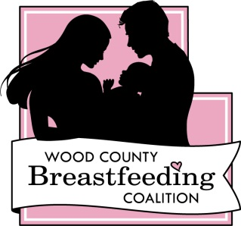
Strategic Plan 2014-2015

The Goals of the Wood County Breastfeeding Coalition are:
Goal 1: To increase breastfeeding support for employees in Wood County.
- By December 31, 2014, train and implement policy change surrounding breastfeeding support for employees and community members at 10 businesses in Wood County.
- By December 31, 2015, update the Wood County community map for breastfeeding moms and make available to the community through different avenues.
Goal 2: To Increase access to breastfeeding resources in Wood County.
- By December 31, 2014, implement postpartum support groups on each end of the county.
- By March 31, 2015, develop a 24/7 breastfeeding line.
- By June 30, 2015, develop a media campaign surrounding the 24/7 breastfeeding line.
- By December 31, 2015, ensure all moms have access to breastfeeding services in Wood County.
Goal 3: To increase access to breastfeeding supplies in Wood County.
- By June 30, 2014, standardize the breast pump access process and ensure all providers are aware of the standardized process.
- By December 31, 2014, provide resources such as bra pump holders, cover-ups, and boppy pillows to moms via the WCBC website.
Goal 4: To increase awareness and support of breastfeeding through community events.
- By May 30, 2014, host the Building Bridges training for area providers.
- By December 31, 2015, host 4 milky mile events and 2 golf outings to raise awareness of breastfeeding and the coalition in the community.
- Annually discuss the coalition’s purpose on the Morning Magazine with WFHR.

